**QUESTION 2 :** Write a program to implement Bresenham’s line algorithm for m<1. **OBJECTIVE :** To learn & implement the concept of plotting a line using Bresenham’s line algorithm. **CODE :**

#include<stdio.h> #include<conio.h> #include<graphics.h> #include<math.h> void main( ) {

int gd = DETECT, gm;

float x1, y1, x2, y2, dx, dy, p, x, y; int i; initgraph(&gd,&gm,"c:\\turboc3\\bgi"); printf("Enter two end points of line: "); scanf("%f%f%f%f", &x1, &y1, &x2, &y2); dx = x2-x1; dy = y2-y1;

x = x1; y = y1; putpixel(x,y,4);

p = (2*dy) - dx; for(i=1; i<=dx; i++)

{

if(p<0) {

p = p + (2*dy); x++;

putpixel(x,y,4); }

else {

p = p + (2*dy) - (2*dx); x++;

y++;

putpixel(x,y,4); }

# OUTPUT :

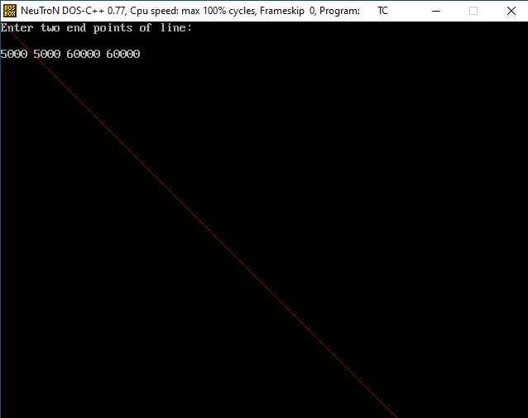

**QUESTION 3 :** Write a program to implement Bresenham’s line algorithm for m>=1. **OBJECTIVE :** To learn & implement the concept of plotting a line using Bresenham’s line algorithm. **CODE :**

#include<stdio.h> #include<conio.h> #include<graphics.h> #include<math.h> void main( ) {

int gd = DETECT, gm;

float x1, y1, x2, y2, dx, dy, p, x, y; int i; initgraph(&gd, &gm,"c:\\turboc3\\bgi"); printf("enter two end points: "); scanf("%f%f%f%f", &x1, &y1, &x2, &y2); dx = x2-x1; dy = y2-y1;

x = x1; y = y1; putpixel(x,y,15); p = (2*dx) - dy;

for(i=1; i<=dy; i++)

{

if (p<0) {

p = p + (2*dx); y++;

putpixel(x,y,15); }

else {

x++; y++;

p = p + (2*dx) - (2*dy);

putpixel(x,y,15); }

# OUTPUT :

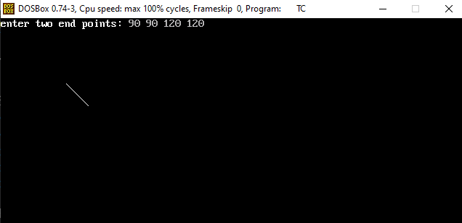

**QUESTION 4 :** Write a program to implement Midpoint Circle Generation algorithm with radius r and centre point (xc, yc).

**OBJECTIVE:** To learn & implement the concept of plotting a circle using Midpoint Circle Generation Algorithm.

## CODE :

#include<stdio.h> #include<conio.h> #include<math.h> #include<graphics.h> void main( ) {

int gd = DETECT, gm; float x, y, r, p, xc, yc;

initgraph(&gd, &gm, "c:\\turboc3\\bgi");

printf("enter the value of x: "); scanf("%f", &x);

printf("enter radius r: "); scanf("%f", &r);

x = 0; y = r;

yc =100; xc =150; p = (5/4) - r;

do {

putpixel(x,y,15); putpixel(x+xc,y+yc,15); putpixel(-x+xc,y+yc,15); putpixel(x+xc,-y+yc,15);

putpixel(-x+xc,-y+yc,15); putpixel(y+xc,x+yc,15); putpixel(-y+xc,x+yc, 15); putpixel(y+xc,-x+yc,15); putpixel(-y+xc,-x+yc,15);

if (p<0) {

x++;

p = p +(2*x)+ 1; }

getch( );

}

else {

}while(x<y);

x++; y--;

p = p + (2*x) - (2*y) + 1; }

# OUTPUT :

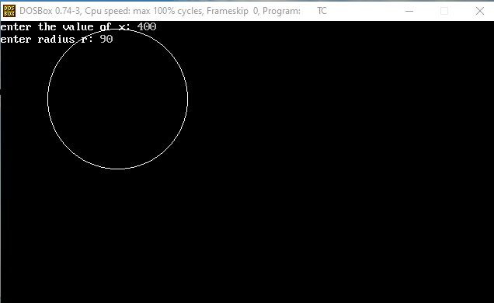

**QUESTION 5 :** Write a program to implement Bresenham Circle Generation algorithm with radius r and centre point (xc, yc).

**OBJECTIVE :** To learn & implement the concept of plotting a circle using Bresenham Circle Generation Algorithm.

## CODE :

#include<stdio.h> #include<conio.h> #include<graphics.h> #include<math.h> void main( ) {

int gd = DETECT, gm; float x, y, r, p, xc, yc;

initgraph(&gd, &gm, "c:\\turboc3\\bgi");

printf("enter the value of x: "); scanf("%f", &x);

printf("enter the radius r:"); scanf("%f", &r);

x = 0; y = r;

xc = 50; yc =100; p = 3 - (2*r);

do {

putpixel(x,y,15); putpixel(x+xc, y+yc, 15); putpixel(-x+xc,y+yc,15); putpixel(x+xc,-y+yc, 15);

putpixel(-x+xc,-y+yc,15); putpixel(y+xc,x+yc, 15);

putpixel(-y+xc,x+yc, 15);

putpixel(y+xc,-x+yc, 15); putpixel(-y+xc,-x+yc,15);

if (p<0) {

x++;

p = p + (4*x) + 6; }

else {

x++; y--;

p = p + (4*x) - (4*y) + 10; }

getch( );

}

}while(x<y);

# OUTPUT :

